DIGITAL LOGIC AND COMPUTER ORGANIZATION
REPORT

TITLE
Smart Trash Bin — Flip-flops & Encoder/Decoder

NAME : SUDEEPTHA TN
DEPARTMENT: AI&DS

INTRODUCTION
In modern urban environments, efficient waste management has become an essential part of maintaining cleanliness and sustainability. The Smart Trash Bin Level Indicator is a simple yet innovative project designed using Digital Logic and Computer Organization (DLCO) concepts to overcome this issue.
This system uses combinational and sequential logic circuits to detect the waste level inside a bin and display its status — Empty, Half Full, or Full. The design employs logic gates, encoders/decoders, and D flip-flops to interpret sensor inputs and store the previous fill level. It demonstrates how digital circuits can be applied to real-world environmental problems, combining fundamental logic principles with automation concepts.

OBJECTIVES
The main objectives of the project are:
- To design a digital logic circuit that monitors and indicates the level of waste inside a trash bin using binary input.
- To apply DLCO concepts such as combinational logic, sequential circuits, and D flip-flops for data storage and state retention.
- To visualize the system using an HTML-based simulation prototype, representing sensor activation, binary encoding, and output display.
- To promote smart waste management by providing a low-cost, logic-based model
CODE
<!doctype html>
<html lang="en">
<head>
<meta charset="utf-8" />
<meta name="viewport" content="width=device-width,initial-scale=1" />
<title>Smart Trash Bin — DLCO Prototype</title>
<style>
:root{font-family:Inter,Segoe UI,Roboto,Helvetica,Arial,sans-serif;color:#111}
body{margin:0;background:linear-gradient(180deg,#f6fbff,#eef6ff);min-height:100vh;display:flex;align-items:center;justify-content:center}
.card{width:920px;background:white;border-radius:12px;box-shadow:0 8px 30px rgba(20,30,60,0.09);padding:22px}
h1{margin:0 0 6px;font-size:20px}
p.lead{margin:0 0 18px;color:#4b5563}
.layout{display:grid;grid-template-columns:320px 1fr;gap:18px}
.panel{background:#fbfdff;border:1px solid #eef5ff;padding:12px;border-radius:10px}
.sensors .row{display:flex;align-items:center;justify-content:space-between;padding:8px 6px}
.switch{display:flex;gap:10px;align-items:center}
.toggle{position:relative;width:52px;height:28px;background:#dbeafe;border-radius:999px;padding:3px;cursor:pointer}
.knob{width:22px;height:22px;background:white;border-radius:50%;box-shadow:0 1px 4px rgba(2,6,23,0.2);transform:translateX(0);transition:transform .18s}
.toggle.on{background:#7dd3fc}
.toggle.on .knob{transform:translateX(24px)}
.leds{display:flex;gap:12px;align-items:center}
.led{width:26px;height:26px;border-radius:50%;background:#e6eefc;box-shadow:inset 0 -2px 6px rgba(0,0,0,0.06)}
.led.on.green{background: #16a34a;box-shadow:0 0 10px rgba(22,163,74,0.45)}
.led.on.yellow{background:#f59e0b;box-shadow:0 0 10px rgba(245,158,11,0.35)}
.led.on.red{background:#dc2626;box-shadow:0 0 12px rgba(220,38,38,0.35)}
.display{display:flex;gap:14px;align-items:center}
.binarystack{background:#0f172a;color:#fff;padding:10px;border-radius:8px;min-width:120px;text-align:center}
.binarystack .bits{font-family:monospace;font-size:20px;letter-spacing:6px}
.status{font-weight:600}
.controls{display:flex;gap:8px;align-items:center;margin-top:12px}
button{background:#0ea5e9;border:none;padding:8px 12px;border-radius:8px;color:white;font-weight:600;cursor:pointer}
button.secondary{background:#94a3b8}
.sevenseg{width:140px;height:60px;background:black;border-radius:8px;padding:12px;display:grid;grid-template-columns:repeat(3,1fr);grid-template-rows:repeat(2,1fr);gap:6px}
.seg{background:#081126;border-radius:6px;display:flex;align-items:center;justify-content:center;color:#9aaed6;font-weight:700}
.info{font-size:13px;color:#334155}
.footer{margin-top:12px;font-size:13px;color:#475569}
.chip{display:inline-block;background:#eef2ff;padding:6px 8px;border-radius:999px;font-weight:600;color:#1e293b}
</style>
</head>
<body>
<div class="card">
<h1>Smart Trash Bin — Flip-flops & Encoder/Decoder</h1>
<p class="lead">Simulates 3 sensors (bottom→top). Uses simple combinational logic and a tiny sequential memory (stores last state). Toggle sensors and click <span class="chip">Apply</span>.</p>

<div class="layout">
<div class="panel sensors">
<div class="row"><strong>Sensors (bottom → top)</strong><span class="info">Each sensor outputs 1 when waste reaches that height</span></div>
<div class="row">
<div class="switch"><label>Level 1 (bottom)</label><div id="t1" class="toggle" data-val="0"><div class="knob"></div></div></div>
<div class="leds"><div id="led1" class="led"></div></div>
</div>
<div class="row">
<div class="switch"><label>Level 2 (mid)</label><div id="t2" class="toggle" data-val="0"><div class="knob"></div></div></div>
<div class="leds"><div id="led2" class="led"></div></div>
</div>
<div class="row">
<div class="switch"><label>Level 3 (top)</label><div id="t3" class="toggle" data-val="0"><div class="knob"></div></div></div>
<div class="leds"><div id="led3" class="led"></div></div>
</div>

<div class="controls">
<button id="apply">Apply Sensors</button>
<button id="clear" class="secondary">Clear Memory</button>
<button id="preset" class="secondary">Random Fill</button>
</div>

<div class="footer">Sequential memory: last computed state is stored (simulates flip-flops). Reload page preserves it.</div>
</div>

<div class="panel">
<div style="display:flex;justify-content:space-between;align-items:center">
<div class="display">
<div class="binarystack">
<div style="font-size:12px;opacity:.8">Binary (top→bottom)</div>
<div id="bits" class="bits">000</div>
</div>

<div style="min-width:220px">
<div style="font-size:13px;color:#64748b">Decoded Status</div>
<div id="status" class="status">Empty</div>
<div id="statusDetail" class="info">No waste detected.</div>
</div>
</div>

<div style="text-align:right">
<div style="font-size:12px;color:#94a3b8">Level LEDs</div>
<div style="display:flex;gap:8px;margin-top:8px;justify-content:flex-end">
<div style="text-align:center"><div id="v1" class="led"></div><div style="font-size:12px;margin-top:6px">L1</div></div>
<div style="text-align:center"><div id="v2" class="led"></div><div style="font-size:12px;margin-top:6px">L2</div></div>
<div style="text-align:center"><div id="v3" class="led"></div><div style="font-size:12px;margin-top:6px">L3</div></div>
</div>
</div>
</div>

<hr style="margin:12px 0;border:none;border-top:1px solid #eef2ff" />

<div style="display:flex;gap:12px;align-items:center">
<div>
<div style="font-size:12px;color:#94a3b8">7-segment style (encoded)</div>
<div class="sevenseg" id="seven">
<div id="s1" class="seg">0</div>
<div id="s2" class="seg">0</div>
<div id="s3" class="seg">0</div>
<div id="s4" class="seg">E</div>
<div id="s5" class="seg">M</div>
<div id="s6" class="seg">P</div>
</div>
</div>

<div style="flex:1">
<div style="font-size:12px;color:#94a3b8;margin-bottom:6px">Truth table (implemented)</div>
<pre style="background:#fbfdff;border-radius:8px;padding:10px;margin:0;font-size:13px;color:#0f172a">Inputs (top→mid→bot) → Status
000 → Empty
001 → Low
011 → Half
111 → Full
Other combos treated as nearest interpretation (combinational logic)
</pre>
</div>
</div>

<hr style="margin:12px 0;border:none;border-top:1px solid #eef2ff" />

<div style="display:flex;justify-content:space-between;align-items:center">
<div>
<div style="font-size:12px;color:#94a3b8">Memory (flip‑flop simulation)</div>
<div id="memory" style="font-weight:700;margin-top:6px">No previous state</div>
<div class="info" style="margin-top:6px">(Apply stores the current computed state in browser storage)</div>
</div>

<div style="text-align:right">
<div style="font-size:12px;color:#94a3b8">Last applied time</div>
<div id="mtime" style="font-weight:700;margin-top:6px">—</div>
</div>
</div>

</div>
</div>
</div>

<script>
// helpers
const get = id => document.getElementById(id);
const toggles = [get('t3'), get('t2'), get('t1')]; // top->bottom for display
const leds = [get('led3'), get('led2'), get('led1')];
const viewLEDs = [get('v3'), get('v2'), get('v1')];

function toggleClick(el){
el.addEventListener('click', ()=>{
const val = el.getAttribute('data-val') === '1' ? '0' : '1';
el.setAttribute('data-val', val);
el.classList.toggle('on', val==='1');
});
}
toggles.forEach(toggleClick);

// read binary from toggles (top->mid->bot)
function readSensors(){
return toggles.map(t=>t.getAttribute('data-val')).join('');
}

// Combinational logic: implement truth table rules and simple prioritization
function interpret(bits){
// bits is string like '010' top->mid->bot
// convert to common pattern with bottom as LSB for easier view
const b = bits; // top mid bot
// If exact patterns exist use them
if(b === '000') return {code:'000', label:'Empty', detail:'No waste detected.'};
if(b === '001') return {code:'001', label:'Low', detail:'Waste reached bottom level.'};
if(b === '011') return {code:'011', label:'Half', detail:'Waste reached mid level.'};
if(b === '111') return {code:'111', label:'Full', detail:'Top level reached — please empty!'};
// fallback rules: if top sensor on, treat as Full
if(b[0] === '1') return {code:'111', label:'Full', detail:'Top sensor triggered.'};
// if mid on, at least Half
if(b[1] === '1') return {code:'011', label:'Half', detail:'Mid sensor triggered.'};
// if only bottom on
if(b[2] === '1') return {code:'001', label:'Low', detail:'Bottom sensor only.'};
return {code:'000', label:'Empty', detail:'No sensors active.'};
}

function updateView(state){
get('bits').innerText = state.code;
get('status').innerText = state.label;
get('statusDetail').innerText = state.detail;

// set small level LEDs (visual)
const map = state.code.split('').map(x=>x==='1'); // top->mid->bot
viewLEDs.forEach((el,i)=>{
el.className = 'led' + (map[i] ? ' on red' : '');
});

// 7-seg style: show code and label letters across segments
get('s1').innerText = state.code[0];
get('s2').innerText = state.code[1];
get('s3').innerText = state.code[2];
const label = state.label.padEnd(3).slice(0,3).toUpperCase();
get('s4').innerText = label[0] || '-';
get('s5').innerText = label[1] || '-';
get('s6').innerText = label[2] || '-';
}

// memory functions (simulate D flip-flops storing last state)
function storeMemory(state){
const now = new Date().toISOString();
localStorage.setItem('st_bin_state', JSON.stringify({state, time:now}));
renderMemory();
}
function clearMemory(){
localStorage.removeItem('st_bin_state');
renderMemory();
}
function renderMemory(){
const raw = localStorage.getItem('st_bin_state');
if(!raw){
get('memory').innerText = 'No previous state';
get('mtime').innerText = '—';
return;
}
const parsed = JSON.parse(raw);
get('memory').innerText = parsed.state.label + ' ('+parsed.state.code+')';
get('mtime').innerText = new Date(parsed.time).toLocaleString();
}

// apply button handler
get('apply').addEventListener('click', ()=>{
const bits = readSensors();
const state = interpret(bits);
updateView(state);
// flash the big LEDs visually
leds.forEach((led,i)=>{
led.className = 'led' + (state.code[i]==='1' ? ' on ' + (i===0? 'red': (i===1? 'yellow':'green')) : '');
});
storeMemory(state);
});

get('clear').addEventListener('click', ()=>{
clearMemory();
// clear UI
leds.forEach(l=>l.className='led');
viewLEDs.forEach(l=>l.className='led');
get('bits').innerText='000';
get('status').innerText='Empty';
get('statusDetail').innerText='No waste detected.';
['s1','s2','s3','s4','s5','s6'].forEach(id=>get(id).innerText='-');
});

get('preset').addEventListener('click', ()=>{
// random sensible pattern
const options = ['000','001','011','111'];
const pick = options[Math.floor(Math.random()*options.length)];
// write toggles (top->mid->bot)
toggles.forEach((t,i)=>{
const v = pick[i];
t.setAttribute('data-val', v);
t.classList.toggle('on', v==='1');
});
});
// init
(function(){
renderMemory();
// initialize display with empty
updateView({code:'000', label:'Empty', detail:'No waste detected.'});
// restore toggles to 0
toggles.forEach(t=>{t.setAttribute('data-val','0');t.classList.remove('on');});
})();
</script>
</body>
</html>

OUTPUT

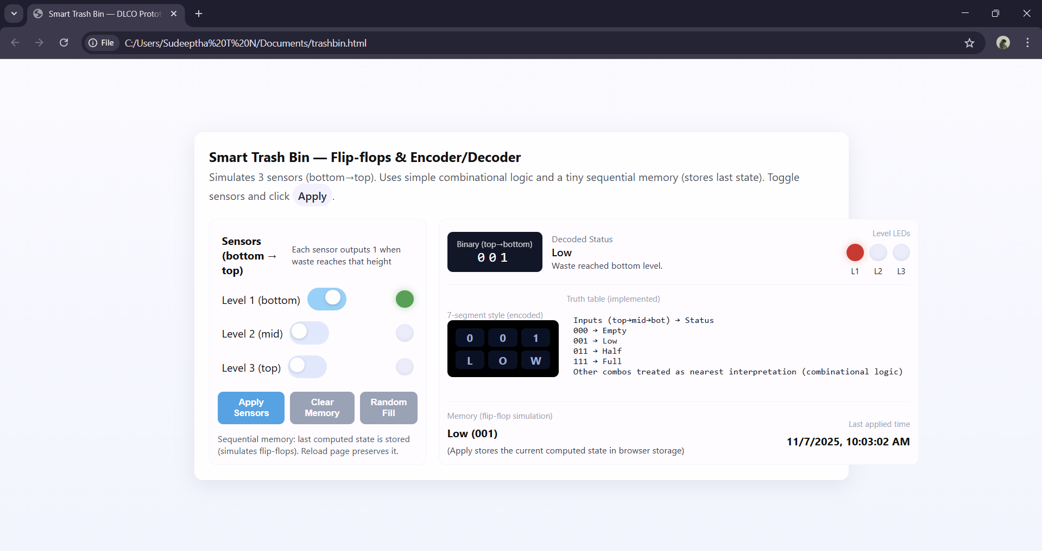

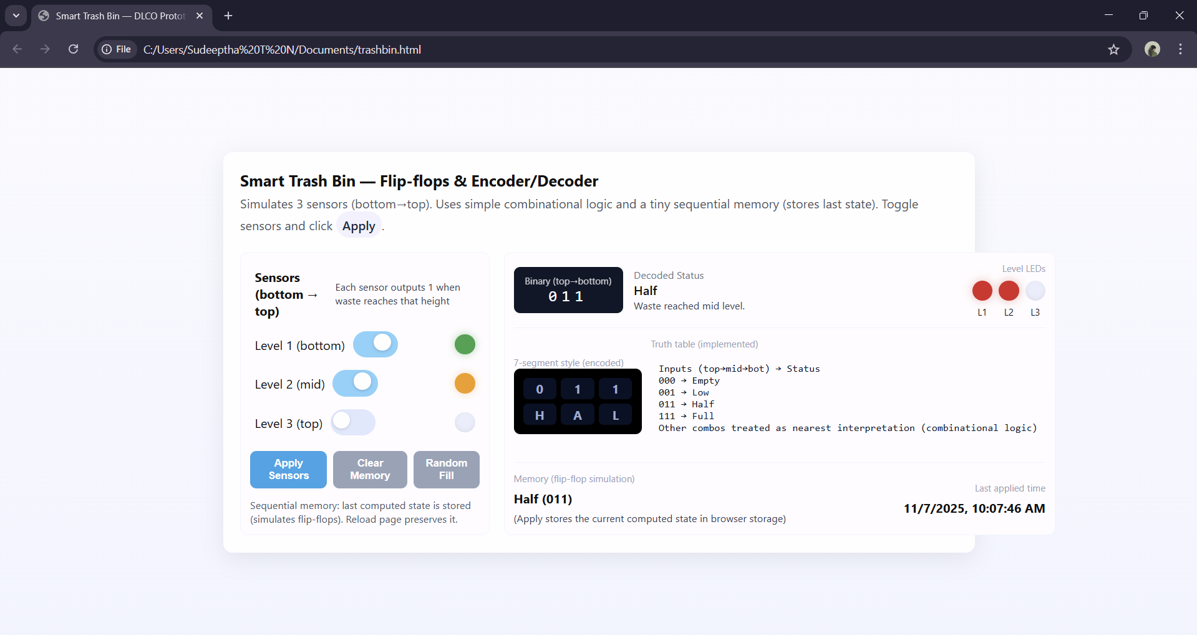

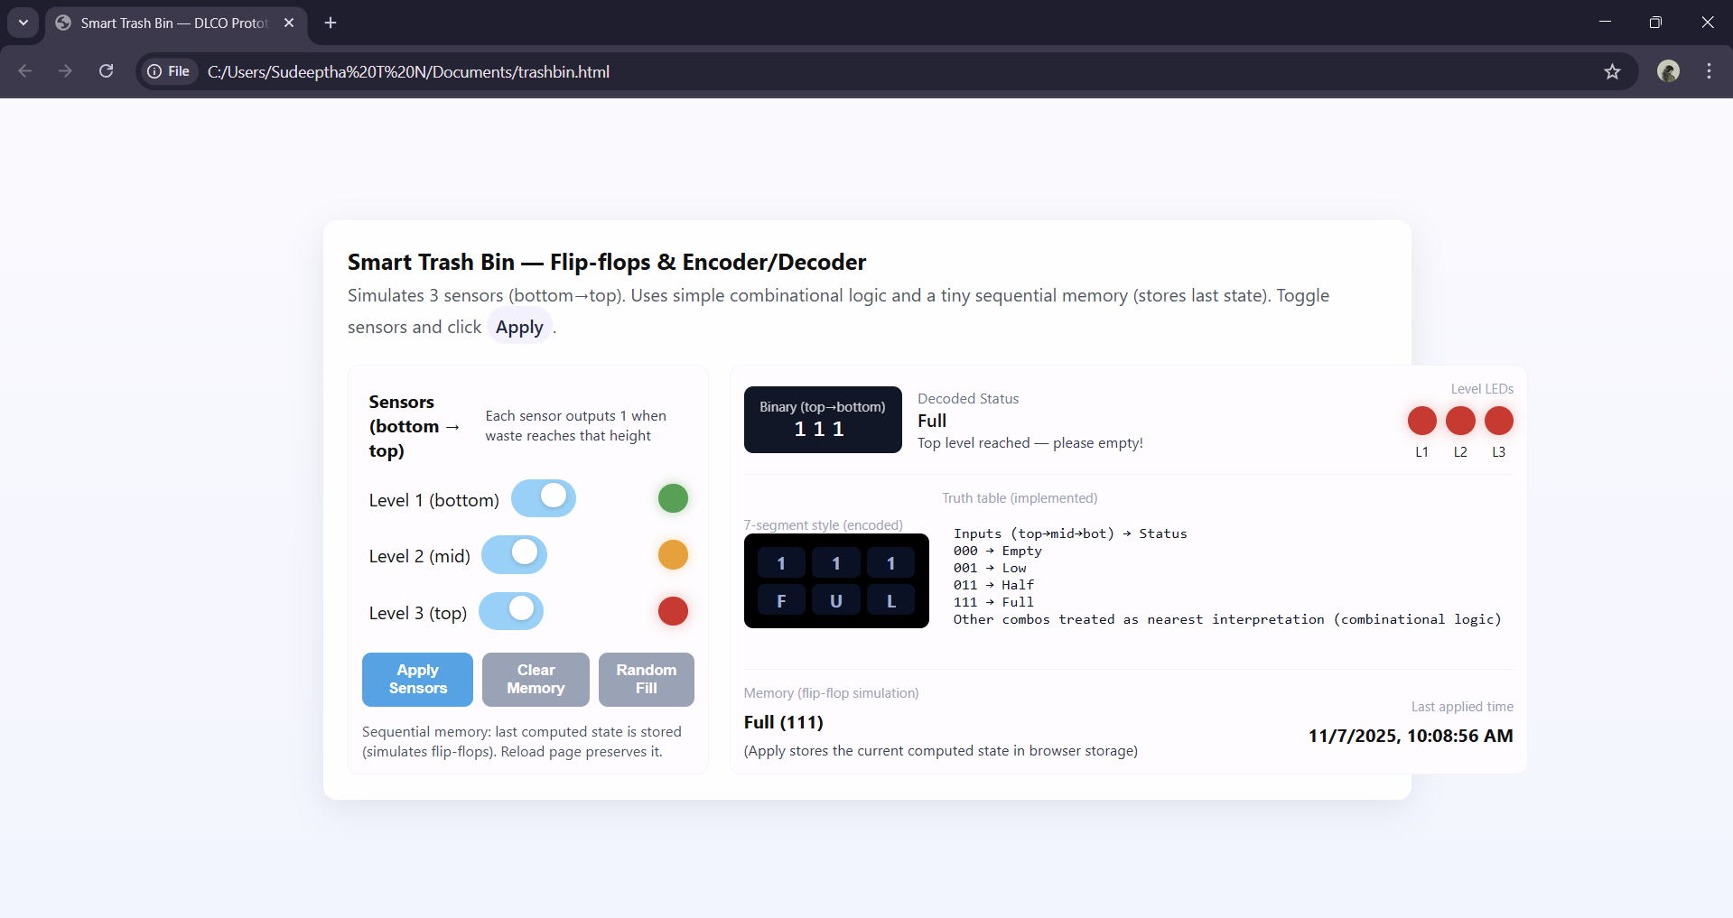

CONCLUSION
The Smart Trash Bin Level Indicator successfully demonstrates how digital logic principles can be applied to solve practical, real-world problems. By using a combination of logic gates, sensors, and D flip-flops, the system efficiently detects the bin’s fill level and stores its previous state, showcasing the integration of combinational and sequential circuits.
The HTML prototype effectively simulates the working of the circuit, providing an interactive visualization of how sensor inputs translate into binary outputs and corresponding status indications. This reinforces key DLCO concepts such as binary encoding, logical decision-making, and state memory.
Overall, the project achieves its objective of building a simple, reliable, and educational model for smart waste management. With minor hardware enhancements, it can be expanded into a fully functional IoT-based smart bin system, proving that fundamental digital logic design can form the foundation of intelligent automation solutions.

